Todo Summary Assistant
DevOps Assessment — End-to-End Implementation, Deployment & Evidence
Documentation from architecture through final deployment and testing

Assessment focus: Docker • GitHub Actions • Docker Hub • AWS EC2 • RDS MySQL • Secrets Manager • Prometheus • Grafana • Nginx • Rollback

Deployed URL :
http://18.61.161.24

1. Project and Assessment Overview
The Todo Summary Assistant is an existing full-stack application enhanced with DevOps capabilities. The goal was to containerize the application, automate CI/CD, deploy it on AWS EC2 with Amazon RDS MySQL, externalize secrets, add monitoring and document operational recovery.

Assessment requirements addressed
- Production-oriented backend and frontend Dockerfiles using multi-stage builds and non-root runtime users.
- Environment-based configuration with no production credentials committed to source control.
- GitHub Actions CI/CD triggered by pushes and pull requests.
- Docker images pushed to Docker Hub using commit SHA versioning.
- Automated EC2 deployment with post-deployment health checks.
- Amazon EC2 application hosting and Amazon RDS MySQL database.
- Private RDS connectivity restricted to the EC2 security group.
- EC2 IAM role for AWS Secrets Manager access.
- Prometheus and Grafana monitoring with Node Exporter and cAdvisor support.
- Meaningful alerts for backend availability and high EC2 CPU.
- Documented failure, rollback, security, testing and troubleshooting procedures.

2. Final Architecture
Full architecture diagram: See the architecture image included in this document.
Developer
|
v
GitHub (git push or git pull)
|
v
GitHub Actions
|
+--> Backend tests
+--> Frontend build
+--> Docker build
+--> SHA tagging
+--> Docker Hub push
|
|
EC2
|
+--> Host Nginx :80
| |
| +--> Frontend container
| +--> Backend container
|
+--> Prometheus
+--> Grafana
+--> Node Exporter
+--> cAdvisor
|
+--> IAM Role
|
v
Secrets Manager
|
v
DB credentials
Backend
|
| MySQL :3306
v
Private Amazon RDS MySQL

Request flow
Internet user
-> EC2
-> Nginx
-> React frontend / Spring Boot API
-> Private RDS MySQL

CI/CD flow
Git push / PR
-> GitHub Actions
-> backend test + frontend build
-> Docker build
-> SHA-tagged images
-> Docker Hub
-> SSH to EC2
-> deploy.sh
-> Secrets Manager
-> Docker Compose
-> health checks
-> success OR automatic rollback

TodoSummaryAssistant/
│
├── Backend/
│ ├── src/
│ ├── Dockerfile
│ ├── pom.xml
│ └── .dockerignore
│
├── Frontend/
│ ├── src/
│ ├── Dockerfile
│ ├── nginx.conf
│ └── package.json
│
├── .github/
│ └── workflows/
│ └── ci-cd.yml
│
├── aws/
│ ├── architecture-diagram.png
│ ├── aws-setup.md
│ └── screenshots/
│
├── docs/
│ ├── DEPLOYMENT.md
│ ├── SECURITY.md
│ ├── TESTING.md
│ ├── TROUBLESHOOTING.md
│ └── screenshots/
│
├── monitoring/
│ ├── prometheus/
│ │ ├── prometheus.yml
│ │ └── alert-rules.yml
│ └── screenshots/
│
├── docker-compose.yml
├── deploy.sh
├── rollback.sh
├── .env.example
├── .gitignore
├── README.md
├── FAILURE_AND_ROLLBACK.md
└── MONITORING_AND_OPERATIONS.md

Next Step: Push the project to GitHub

1. Git init

2. Git add .

3. Git commit -m "Initial DevOps setup"

4. Git push

GitHub Actions:
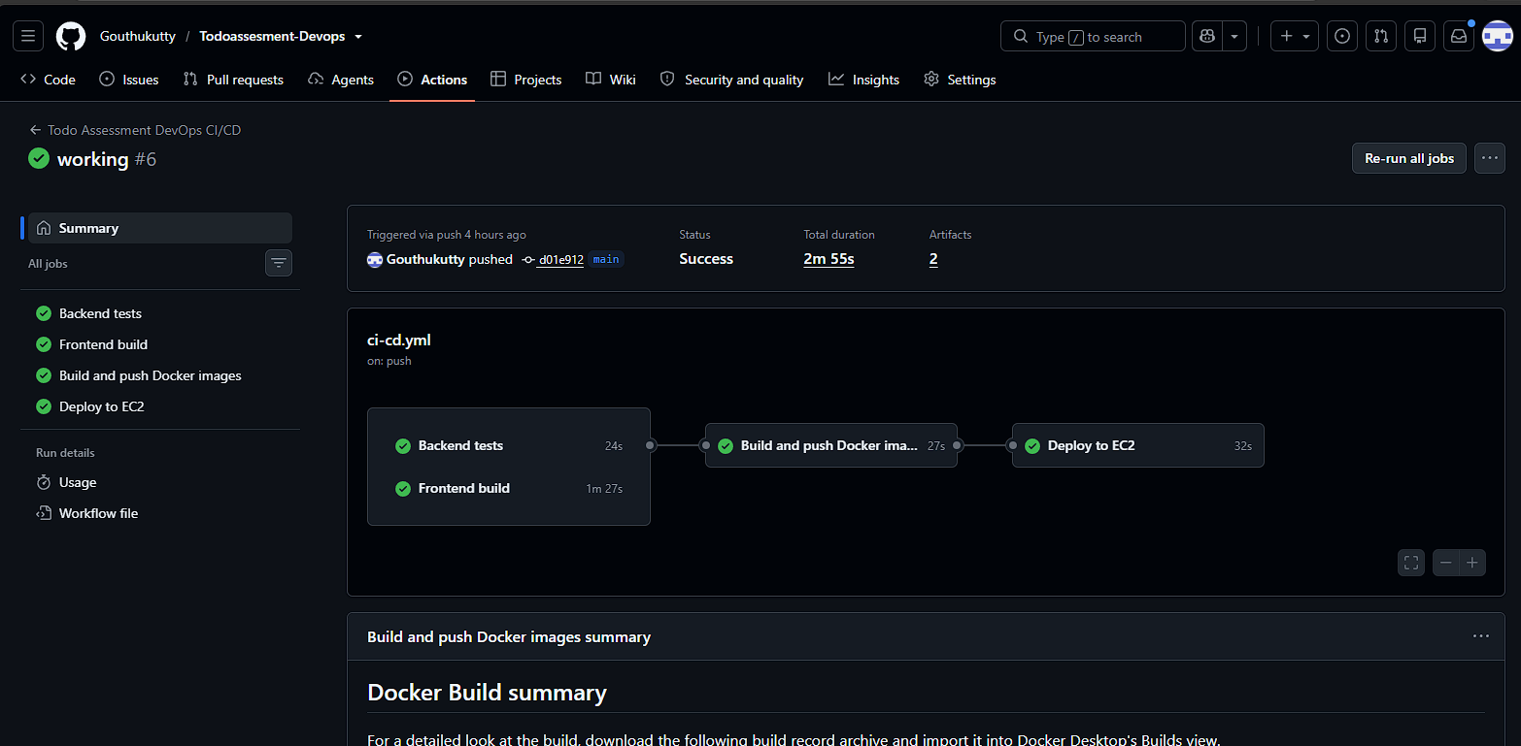

1. Build Frontend
2. Test Backend
3. Build Docker images
4. Build and Push images to Docker Hub

5. Deploy to EC2

EC2

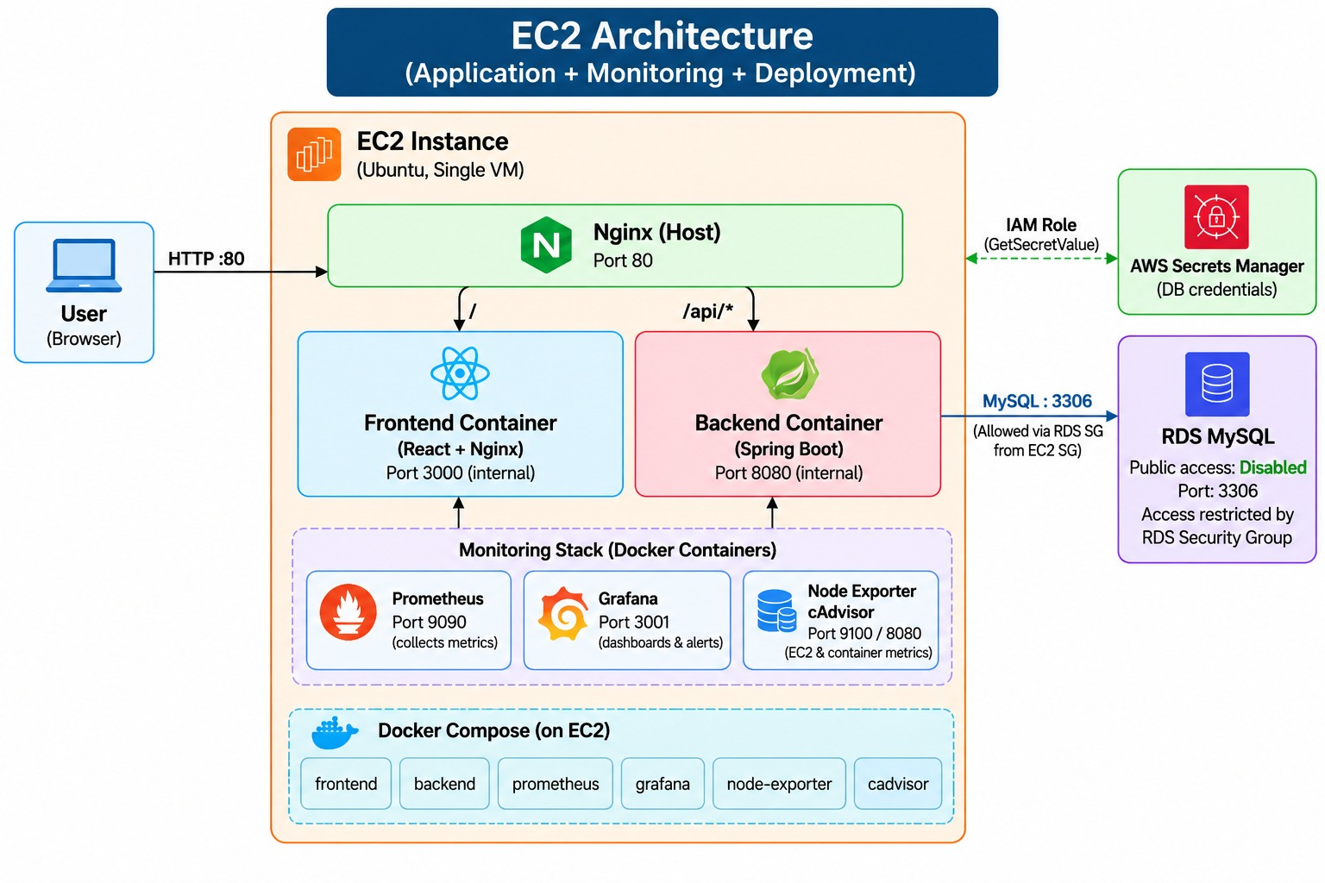

13. If a health check fails, the deployment script automatically rolls back to the previous successful SHA.
12. If both health checks pass, the deployment is marked successful and the SHA is saved as the current version.
11. Backend and frontend health checks are executed after deployment.
10. Docker Compose starts or updates the application and monitoring containers.
9. Docker pulls the SHA-tagged backend and frontend images from Docker Hub.
8. deploy.sh retrieves the RDS username and password from AWS Secrets Manager using the EC2 IAM role.
7. EC2 runs deploy.sh with the selected Git commit SHA.
6. GitHub Actions connects to EC2 using the configured SSH secrets.
docker-compose.yml
Next Step: Configure and verify monitoring
- Backend runs the Spring Boot application and connects to the RDS MySQL database.
- Frontend runs the React application using Nginx.
- Prometheus collects application and system metrics from the backend, Node Exporter, and cAdvisor.
- Grafana displays these metrics through dashboards and alerts.
- Docker Compose runs and manages all these services together on the EC2 instance.

Next:

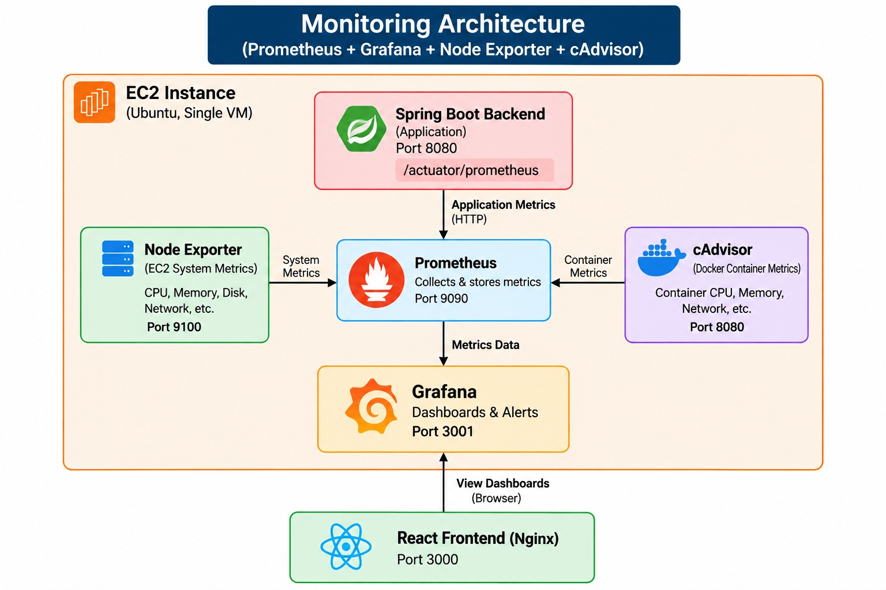

4. Verify the Grafana dashboard and configured alerts.
3. Connect Grafana to Prometheus as the monitoring data source.
2. Verify Prometheus targets for the backend, Node Exporter and cAdvisor.
1. Start Prometheus, Grafana, Node Exporter and cAdvisor using Docker Compose.

Prometheus
Prometheus is used to collect and store monitoring metrics from the application and EC2 server.
It collects metrics from Spring Boot, Node Exporter, and cAdvisor.
Grafana uses Prometheus data to display dashboards and alerts.
URLs
Prometheus UI:
http://18.61.161.24:9090
Prometheus Targets:
http://18.61.161.24:9090/targets
Backend Metrics:
http://backend:8080/actuator/prometheus
Ports
- Prometheus: 9090
Node Exporter:
http://18.61.161.24:9100/metrics
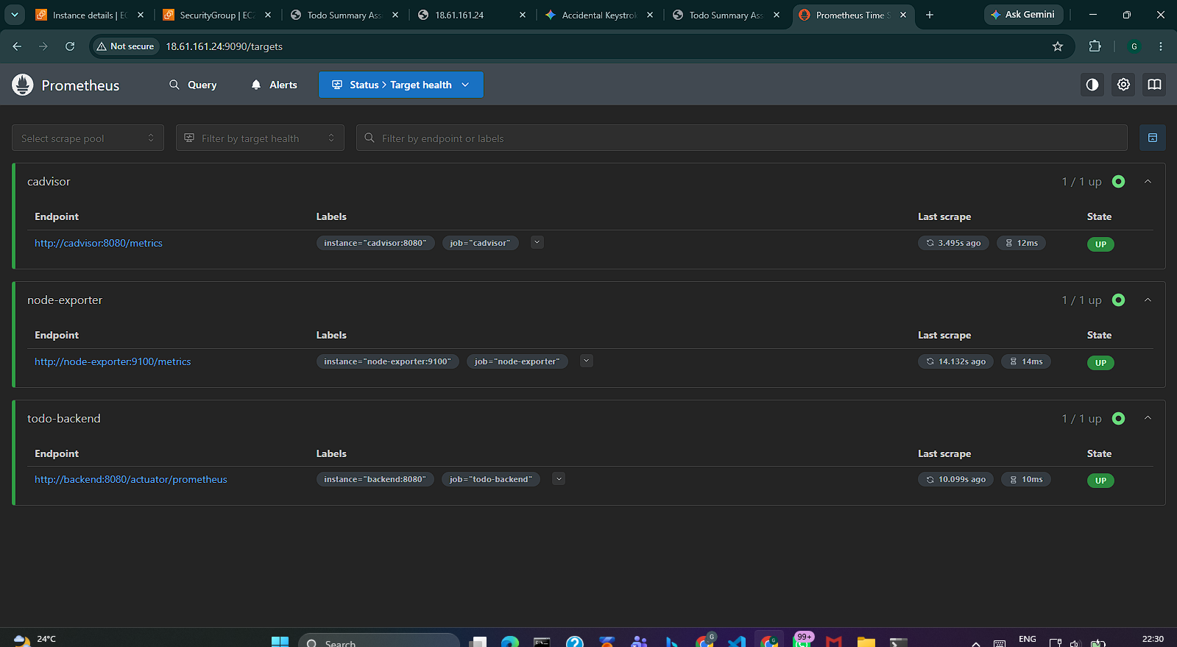

Node Exporter
Node Exporter is used to collect EC2 server-level metrics.
It monitors CPU, memory, disk, and network usage of the EC2 instance.
Prometheus collects these metrics from Node Exporter.
URL
Node Exporter:
http:// http://18.61.161.24:9100/metrics
Grafana
- Node Exporter: 9100

cAdvisor
cAdvisor is used to monitor Docker container metrics.
It collects information such as container CPU, memory, and resource usage.
Prometheus collects these container metrics for monitoring.
URL
cAdvisor:
http:// http://18.61.161.24:8080/metrics
Port
- cAdvisor: 8080

Grafana
Grafana is used to visualize the metrics collected by Prometheus.
It provides dashboards for CPU, memory, disk, backend requests, errors, and application metrics.
It also helps configure alerts when a monitored value crosses a defined limit.
URL
Grafana:
http://18.61.161.24:3001
Port
- Grafana: 3001
Simple Flow
EC2 / Backend → Prometheus → Grafana → Dashboard & Alerts
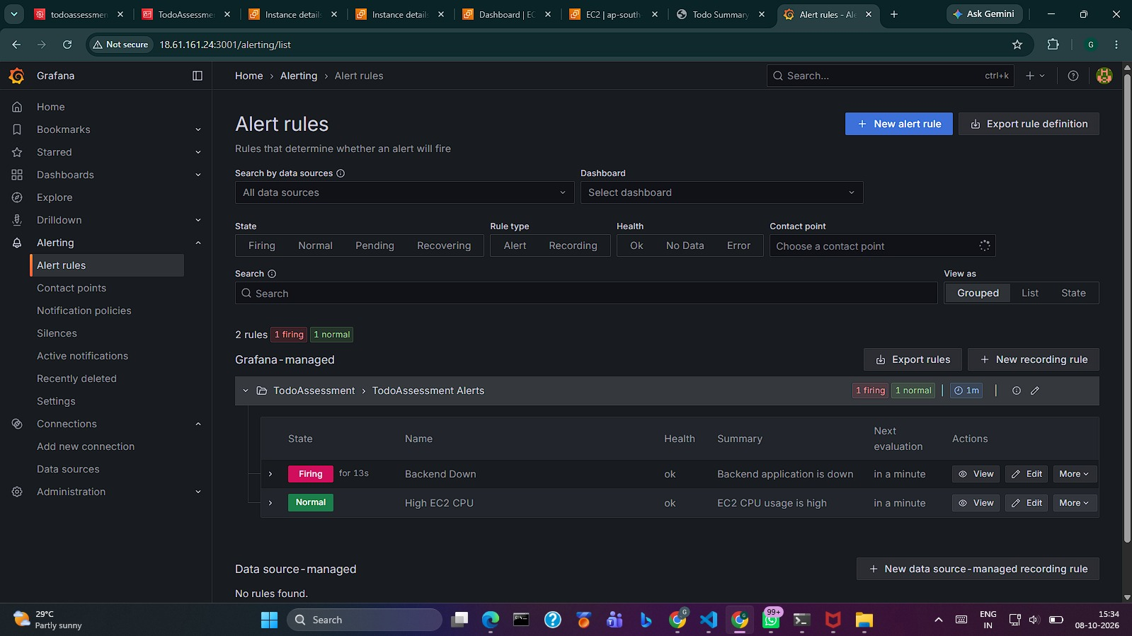

Amazon RDS
Amazon RDS is used to host the MySQL database for the Todo Summary Assistant.
The Spring Boot backend connects to RDS using the RDS endpoint on port 3306.
RDS provides managed database services such as backups, monitoring, and security controls.
How RDS is Secured
- Public access: Disabled — RDS cannot be directly accessed from the Internet.
- Security Group: Port 3306 allows connections only from the EC2 Security Group.
- No 0.0.0.0/0: The database port is not open to everyone.
- Image: AWS Secrets Manager evidence screenshot
- IAM Role: EC2 uses an IAM role to securely retrieve the database credentials.
RDS Connection
RDS Endpoint:
todoassessment-db.cnkam8qo0w3d.ap-south-2.rds.amazonaws.com
Port: 3306
Database: todoapp
Simple explanation:
The RDS database is not publicly accessible. Only the EC2 instance is allowed to connect to RDS through port 3306 using the RDS Security Group, while database credentials are securely stored in AWS Secrets Manager.

AWS Secrets Manager

Images and prof: C:\Users\GOUTHAM\Desktop\TodoSummaryAssistant_Docker_CICD_Only\screenshots_evidence\aws\secrets-manager.png

AWS Secrets Manager is used to securely store sensitive database credentials.
In our project, the RDS username and password are stored in Secrets Manager instead of the code or .env file.
The EC2 instance uses its IAM Role to securely retrieve these credentials during deployment.
Secret Details
Secret Name:
todoassessment/rds
Stored Values:
- username
- password
AWS Region:
ap-south-2
Security
- Database credentials are not committed to GitHub.
- EC2 gets permission only to read this specific secret.
- The IAM Role uses secretsmanager:GetSecretValue.
- deploy.sh retrieves the credentials and passes them to the backend container.
Simple Flow
EC2 → IAM Role → Secrets Manager → RDS Credentials → Spring Boot Backend

Rollback
Rollback is used when a new deployment fails.
The previous working version is restored using its Git SHA.
The application is then checked again to make sure it is working. TodoSummaryAssistant_DevOps_End…
Flow:
New Version → Health Check → Failed → Previous Version → Health Check → Working

deploy.sh
- deploy.sh automates the deployment process on EC2.
- It gets database credentials from AWS Secrets Manager using the EC2 IAM Role.
- It pulls Docker images, starts the containers, and performs health checks.
- If the health check fails, it automatically rolls back to the previous successful version.

Important Commands & URLs

Git / GitHub
git init
git add .
git commit -m "DevOps setup"
git push
EC2 / Docker
cd /home/ubuntu/todolistassesment
docker ps
docker compose ps
docker compose pull
docker compose up -d
docker compose logs backend
Deployment
./deploy.sh <IMAGE_TAG>
Health Checks
curl http://127.0.0.1:8081/actuator/health
curl http://127.0.0.1:3000/health
curl -I http://127.0.0.1/
Nginx
sudo nginx -t
sudo systemctl reload nginx
sudo systemctl status nginx
AWS Secrets Manager
aws secretsmanager get-secret-value \
--secret-id todoassessment/rds \
--region ap-south-2
Prometheus
http://18.61.161.24:9090
http://18.61.161.24:9090/targets
http://backend:8080/actuator/prometheus
Node Exporter
http://18.61.161.24:9100/metrics
cAdvisor
http://18.61.161.24:8080/metrics
Grafana
http://18.61.161.24:3001
RDS
Endpoint:
todoassessment-db.cnkam8qo0w3d.ap-south-2.rds.amazonaws.com

Port:
3306
Docker Hub
gouthukutty/todoassessment-backend
gouthukutty/todoassessment-frontend
Application
http://18.61.161.24

3. DevOps Changes Applied
- Backend Dockerfile: multi-stage Maven build and small Java runtime image.
- Backend container runs as a non-root application user.
- Frontend Dockerfile: multi-stage Node build followed by an Nginx runtime.
- Frontend container runs as a non-root runtime user.
- Database configuration moved to environment variables.
- CORS configuration made environment-driven.
- Spring Boot Actuator and Micrometer Prometheus metrics enabled.
- Frontend and backend health endpoints added/configured for deployment checks.
- Docker Compose added for application and monitoring services.
- GitHub Actions added for test/build/image/deployment automation.
- deploy.sh retrieves database credentials from AWS Secrets Manager.
- SHA-tagged images make deployments traceable and rollback-capable.
- Automatic rollback added when post-deployment health checks fail.

4. Docker and Containerization

Backend
Build stage: Maven + Java
|
v
Spring Boot JAR
|
v
Runtime image
|
v
Non-root app user
|
v
Port 8080

Frontend
Build stage: Node.js
|
v
React production build
|
v
Nginx runtime image
|
v
Non-root runtime
|
v
Port 8080

Production Compose services
- backend
- frontend
- prometheus
- node-exporter
- cadvisor
- grafana
The production database is not containerized; it runs on Amazon RDS MySQL.

5. CI/CD Pipeline
GitHub Actions is used as the CI/CD platform. The pipeline validates the application, builds Docker images, publishes them to Docker Hub, and deploys a selected commit SHA to EC2.

Pipeline stages
- Checkout source code.
- Set up Java and run backend tests.
- Set up Node.js, install frontend dependencies and build the frontend.
- Build backend and frontend Docker images.
- Tag images using the Git commit SHA and latest for main deployments.
- Push images to Docker Hub.
- Connect to EC2 using SSH.
- Run deploy.sh with the image SHA.
- Retrieve database credentials from Secrets Manager.
- Pull the requested images and start Docker Compose.
- Check backend /actuator/health.
- Check frontend /health.
- Record the new SHA only after successful health checks.
- Automatically roll back to the previous successful SHA if health checks fail.

CI/CD secrets
- DOCKERHUB_USERNAME
- DOCKERHUB_TOKEN
- EC2_HOST
- EC2_USERNAME
- EC2_SSH_KEY
No AWS access key is required by the EC2 host because it uses an IAM role.

6. AWS Deployment

EC2
- Ubuntu EC2 instance hosts Docker, Docker Compose, host-level Nginx and the monitoring stack.
- Application deployment directory: /home/ubuntu/todolistassesment/
- Application images are pulled from Docker Hub by commit SHA.

RDS MySQL
- Database: todoapp.
- Engine: MySQL.
- RDS is not publicly accessible.
- MySQL port 3306 is restricted to the EC2 security group.
- The application connects using the RDS endpoint.

IAM and Secrets Manager
EC2
|
| IAM Role: TodoAssessment-EC2-Role
v
Secrets Manager
|
| username + password
v
deploy.sh
|
| environment variables
v
Spring Boot
|
| MySQL 3306
v
RDS
The IAM policy is least-privilege for retrieving the required RDS secret. Static AWS access keys are not used on EC2.

7. Nginx and Application Routing
Nginx runs as a system service on the EC2 Ubuntu host and is intended as the public application entry point.
Internet
|
v
Nginx :80
|
+--> frontend -> 127.0.0.1:3000
|
+--> /api/ -> 127.0.0.1:8081
Verified behavior: the root application request returned HTTP 200. The /api/ test returned a backend JSON 404, which confirms that Nginx forwarded the request to the backend rather than serving a local Nginx error.

8. Monitoring Architecture
Spring Boot
|
| /actuator/prometheus
v
Prometheus
|
+--> Grafana
|
+--> Node Exporter
|
+--> cAdvisor

Current dashboard coverage
- Backend availability
- Backend request rate
- Backend error rate
- EC2 CPU usage
- EC2 memory usage
- EC2 disk usage
- JVM heap usage
- JVM live threads
- JVM garbage collection activity

Latency limitation
The current Spring Boot metrics expose request duration sum, count and max, but not histogram buckets. Therefore a true P95 latency metric is not claimed. Average request latency can be derived from duration sum divided by request count.

cAdvisor limitation
cAdvisor is deployed and scraped, but the current EC2 Docker storage/cgroup environment limits some per-container metrics. The documentation therefore does not claim complete per-container observability where the runtime does not provide it reliably.

Alerts
- Backend Down — critical; fires when the backend Prometheus target is unavailable for the configured duration.
- High EC2 CPU — warning; fires when EC2 CPU remains above 80% for the configured duration.

9. Deployment and Health Checks
cd /home/ubuntu/todolistassesment
./deploy.sh <IMAGE_TAG>

Health checks
- Backend: http://127.0.0.1:8081/actuator/health
- Frontend: http://127.0.0.1:3000/health
- Deployment waits for both services to become healthy.
- Only after both pass is the image tag written to .current_tag.

Current verified successful deployment
Image tag: d01e9124f7caaf5c9c258c7fdc580786169430d1

10. Rollback and Failure Handling
The deployment script stores the last successful image SHA in .current_tag. If a new version fails its health checks, the script pulls the previous images and starts the previous version.
New deployment
|
v
Health checks
|
+--+--+
| |
PASS FAIL
| |
v v
Keep Rollback
new previous SHA
version |
v
Health checks
|
Recovery

Rollback test performed
A controlled deployment-failure test was performed by temporarily forcing the deployment health check to fail. The script detected the failure, automatically restored the previous successful SHA, verified backend and frontend health, and reported ROLLBACK SUCCESSFUL. The temporary test modification was then restored.

11. Testing and Validation

Validated successfully
- Prometheus configuration syntax.
- Prometheus alert rule syntax.
- GitHub Actions deployment flow.
- Docker image build/push/deployment flow in the working environment.
- Backend health check after deployment.
- Frontend health check after deployment.
- Automatic rollback after a forced deployment health-check failure.
- Nginx configuration syntax after removing a duplicate server block.
- Nginx application routing.
- RDS private accessibility configuration.
- RDS security-group restriction to EC2 security group.
- EC2 IAM role access to Secrets Manager.
- Database credential retrieval during deployment.
- Grafana Backend Down alert firing and recovery.

Not claimed as fully validated
- True P95 latency, because histogram buckets are not currently exposed.
- Complete per-container cAdvisor metrics, because the current EC2 runtime has cAdvisor limitations.
- HTTPS/TLS, unless separately configured with a certificate and verified.
- Multi-AZ RDS recovery, because it is not part of the verified deployment state.

12. Security Controls
- No production passwords, API keys or AWS access keys should be committed.
- Database credentials are stored in AWS Secrets Manager.
- EC2 uses an IAM role instead of static AWS keys.
- RDS is not publicly accessible.
- RDS port 3306 accepts traffic from the EC2 security group.
- Backend and frontend containers use non-root runtime users.
- Application configuration is externalized through environment variables.
- Monitoring and administrative ports should remain restricted to approved access paths.
- Commit SHA image tags provide deterministic deployment and rollback.

13. Evidence Screenshots
All links below are relative links to screenshot files. When this Word document is kept together with its screenshots folder, clicking a link opens the corresponding image.

Available evidence
AWS — RDS instance: Open screenshot
AWS — RDS security group: Open screenshot
AWS — EC2 security group: Open screenshot
AWS — Secrets Manager: Open screenshot
Deployment — successful deployment: Open screenshot
Deployment — running containers: Open screenshot
Deployment — health check: Open screenshot
Deployment — SHA restore: Open screenshot
Monitoring — backend down firing: Open screenshot
Monitoring — alert normal/recovered: Open screenshot
Monitoring — backend down pending: Open screenshot
Architecture diagram: Open screenshot

Screenshots still to capture
- AWS EC2 instance details — ec2-instance.png
- RDS Publicly Accessible = No — rds-not-public.png
- IAM role and Secrets Manager permission — iam-role.png
- Successful GitHub Actions run — github-actions-success.png
- Docker Hub backend/frontend repositories with SHA tags — dockerhub-images.png
- Application running through Nginx — application-running.png
- Nginx routing verification — nginx-routing.png
- Prometheus Targets page showing backend, node-exporter and cAdvisor UP — prometheus-targets.png
- Final Grafana dashboard — grafana-dashboard.png
- Backend Down recovered/Normal state — backend-down-recovered.png
- High CPU alert configuration — high-cpu-alert.png
- Complete automatic rollback terminal output — rollback-test.png

14. Recommended Final Repository Structure
TodoSummaryAssistant/
|
+-- Backend/
| +-- todo-summary-assistant/
|
+-- Frontend/
| +-- todo/
|
+-- .github/
| +-- workflows/
| +-- ci-cd.yml
|
+-- aws/
| +-- aws-setup.md
| +-- architecture-diagram.png
| +-- screenshots/
|
+-- docs/
| +-- AWS_ARCHITECTURE.md
| +-- DEPLOYMENT.md
| +-- MONITORING_AND_OPERATIONS.md
| +-- SECURITY.md
| +-- TESTING.md
| +-- TROUBLESHOOTING.md
| +-- PROJECT_STATUS.md
| +-- REPOSITORY_CHECKLIST.md
| +-- screenshots/
|
+-- monitoring/
| +-- prometheus/
| | +-- prometheus.yml
| | +-- alert-rules.yml
| +-- README.md
| +-- screenshots/
|
+-- docker-compose.yml
+-- deploy.sh
+-- rollback.sh
+-- .env.example
+-- README.md
+-- FAILURE_AND_ROLLBACK.md
+-- MONITORING_AND_OPERATIONS.md

15. Final Submission Checklist
- ☐ Backend Dockerfile present and production-oriented.
- ☐ Frontend Dockerfile present and production-oriented.
- ☐ Both runtime containers use non-root users.
- ☐ Secrets externalized.
- ☐ GitHub Actions workflow present.
- ☐ Docker Hub images versioned by commit SHA.
- ☐ EC2 deployment automated.
- ☐ Post-deployment health checks implemented.
- ☐ Automatic rollback tested.
- ☐ RDS MySQL private.
- ☐ RDS access restricted to EC2 security group.
- ☐ EC2 IAM role configured.
- ☐ Prometheus configured.
- ☐ Grafana configured.
- ☐ Node Exporter configured.
- ☐ cAdvisor included with limitations documented.
- ☐ Two meaningful alerts configured.
- ☐ Failure and rollback scenarios documented.
- ☐ Monitoring and operations documented.
- ☐ Architecture diagram included.
- ☐ Evidence screenshots collected.
- ☐ No real secrets committed.

16. Important Operational Notes
Use deploy.sh for normal production redeployment because it retrieves database credentials from Secrets Manager before starting the backend. A direct docker compose restart without the credential-injection step can cause the backend to start without a database password.
The assessment documentation intentionally distinguishes verified implementation from optional or unverified capabilities. This includes P95 latency, complete cAdvisor container metrics, HTTPS and Multi-AZ recovery.

